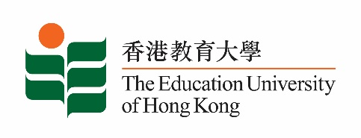
致： 傳媒機構採訪主任 (共 2頁) 3 December 2021
To : News Editors (total: 2 pages)

香港教育大學2021年12月6日至19日可供採訪之活動一覽
The Education University of Hong Kong (EdUHK) Events Calendar for 6 to 19 December 2021
本校誠邀 貴機構派員採訪下列活動。傳媒查詢，請聯絡教大傳訊處（電話：2948 6050）。
You are cordially invited to cover the events below. For media enquiries, please contact the Communications Office at 2948 6050.

因應2019冠狀病毒疫情，以下活動或有人數限制，傳媒請預先向主辦部門登記。
In light of the COVID-19 pandemic, there may be restrictions on the number of participants for the following event(s). Please contact the respective organiser(s) / department(s) for prior registration.

- 教大大埔校園 （新界大埔露屏路十號） / EdUHK Tai Po Campus (10 Lo Ping Road, Tai Po, New Territories)

日期  Date | 時間  Time | 活動  Event | 地點  Venue | 主辦部門及公眾查詢  Organiser &  Public Enquiry | 備註  Remarks
2021-12-18 | 2:30 pm –  4:30 pm | 2021年文學月會 / 香港文學專題講座︰「妙筆呈錦繡──香港粵劇劇本共賞」系列：唐劇面面觀  Monthly Literary Talk 2021 / Subject Talk on Hong Kong Literature: "Appreciating Cantonese Opera: Scripts by Hong Kong Playwrights" Series: Tong Dik-sang's Works: A Multifaceted Glimpse  主持 / Moderator:  梁寶華教授  Professor Leung Bo-wah  講者 / Speaker:  朱少璋博士  Dr Chu Siu-cheung | 香港中央圖書館  （地下演講廳）  Hong Kong Central Library (Lecture Theatre, G/F) | 合辦機構 / Co-Organiser:  康樂及文化事務署香港公共圖書館與教大粵劇傳承研究中心  Hong Kong Public Libraries, Leisure and Cultural Services Department and  Research Centre for Transmission of Cantonese Opera (RCTCO), EdUHK  查詢 / Enquiries:  王先生Mr Wong  電話 / Tel:  2948 7856 | 免費入場，名額有限，先到先得。  Seats are limited. Free admission on a first come, first served basis.  詳情 / Details:  https://www.eduhk.hk/rctco/ch/news.php

